Law 1 – The Field of Play
Fill in the labels from the parts of the field below: Provide the distance between the following:
1.___________________ 7. __________________ Center mark to center circle = ______ yards
2.___________________ 8. __________________ Corner Arc to corner flag = _____ yard
3.___________________ 9. __________________ Optional mark to corner arc = _____yards
4.___________________ 10. __________________ Goal area to goal line = ______ yards
5.___________________ 11. __________________ Penalty Area to goal line = ______ yards
6.___________________ 12. __________________ Penalty mark to goal line = ______ yards
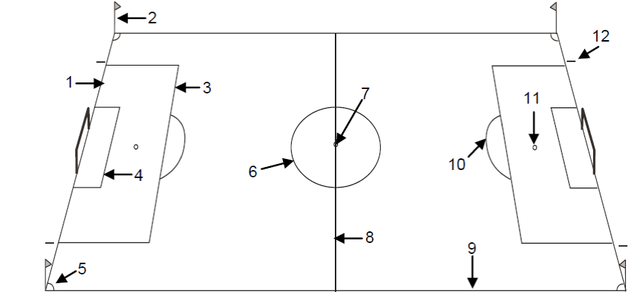
Penalty Arc to penalty mark = ______ yards

Goals MUST be securely ________________
Or the game CANNOT be played.
Lines are a part of the area they mark. If
a foul occurs on the Penalty Area line, is it
considered in the Penalty Area? ________
Is the Penalty Arc part of the Penalty Area? _____

Law 2 – The Ball
It is the responsibility of the ____________________ to inspect all the balls that are used in the game. The most important characteristic of the ball is that it must be ________________.

Law 3 – The Number of Players
The number of Players may change with the age group. Check the rules of competition before you arrive at your game. The following questions use the FIFA requirements for Law 3.
Maximum number of players on the field for one team = _______ One player must be the ______________
Minimum number of players on the field for one team = _______ One player must be the ______________
One team has fewer than 7 players at game time. Should the Referee allow the game to be started? _____
The Referees are required to check in the players before each match. If the game is running behind time, can you skip this step? _________
Can a coach be on the team sideline if they don’t have a coach card? ____________
Anyone not named on the team list as a player, substitute or team official is an ____________ ____________. If they interfere will play, play is stopped and restarted with a ________________ ___________.

Law 4 – Player’s Equipment
Five pieces of mandatory equipment (hint the 5 S’s):
1. __________________________________ 4. ____________________________
2. __________________________________ 5. ____________________________
3. __________________________________
Goalkeepers must wear different colors than the teams. The reason for this is: ________________________________
The primary consideration for shoes is that they be _____________. Are tennis shoes allowed? Yes or No
Are players allowed to wear jewelry that is not medically or religiously required? Yes or No
A player is wearing earrings. They tell the Referee that they just got their ears pierced and if they take them out, they will close. What should the Referee do? _____________________________________________________

Law 5 – The Referee
The primary Duties and Powers of the Referee are:
1. __________________________________ 4. ____________________________
2. __________________________________ 5. ____________________________
3. __________________________________
Is a Referee allowed to change his/her decision if the realize their decision in incorrect, prior to a restart? Yes or No
If a player is seriously injured in the opinion of the Referee, what should they do immediately? _________ _________
The Referee should punish the more _________ offense when more than one offense is commented at the same time.
Please match the following Referee Signals:
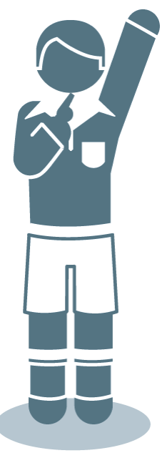
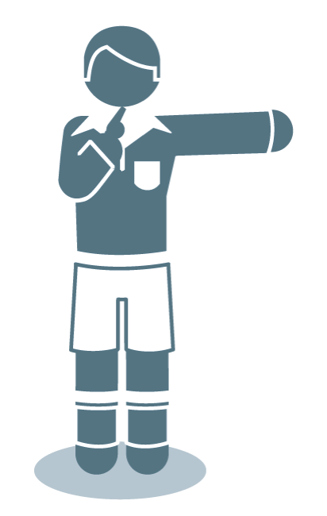
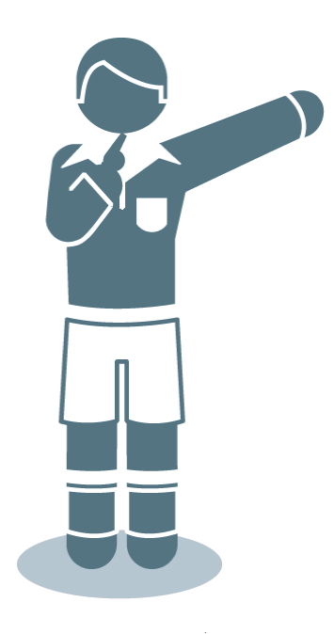
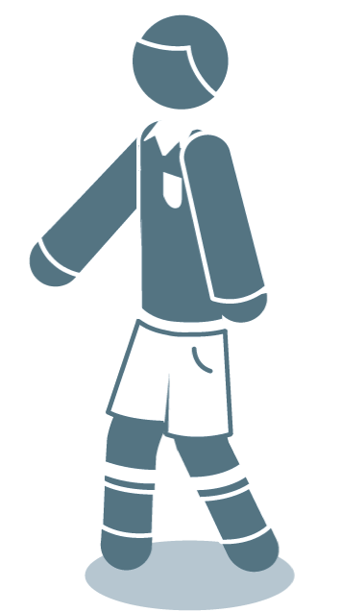
- Direct Free Kick
- Indirect Free Kick
- Corner Kick
- Goal Kick
______ ______ ______ ______

Law 6 – The Other Match Officials
The Assistant Referees indicate the following to the Referee:
1. __________________________________ 3. ____________________________
2. __________________________________ 4. ____________________________
The Assistant Referee should always be even with: (circle one)
A. The 2nd to the last defender B. The Ball C. Either A or B, whichever is closer to the goal line.
Is an Assistant Referee allowed to signal a foul that the Referee was not able to see? Yes or No

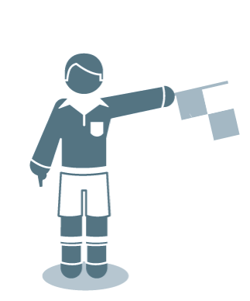
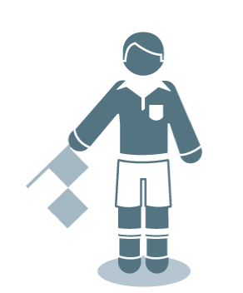
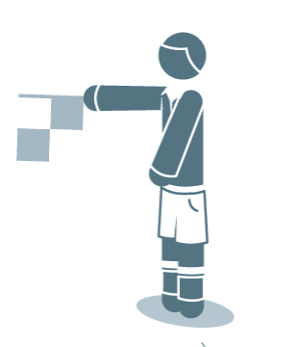
Please match the following Assistant Referee Signals:
- Corner Kick
- Throw-in
- Substitution
- Goal Kick ______ ______ ______ ______

Law 7 – The Duration of the Match
The Duration of the match may vary by age. Check the rules of competition before your game. FIFA says:
A game consists of _________ equal halves of _____________ minutes.
Must a game have a half time period? Yes or No
Allowances for time lost: (circle those that apply)
Substitutions Removal of Injured Players Any other reason
Assessment of Injured Players Wasting time
The amount of time added to each period is up to the __________________________.

Law 8 – The Start and Restart of Play
A ball in in play from a kickoff when it is ______________ and ____________ ___________.
All players must be in their own ______________ of the field of play at a kick-off, except for the __________.
When is a kick-off the correct start/restart of play?
- Start of the game C. At the start of the second half E. All of the above
- After a goal is scored D. At the start of extra periods
Can a player score directly from a Kickoff? Yes or No
If a player taking the kickoff touches the ball a 2nd time before any other player touches it, which type of free kick is awarded to the opposing team? Direct Free Kick or Indirect Free Kick
For a dropped ball, the ball should be dropped from the waist height of the _________________.
The ball is in play from a dropped ball when the ball touches the ______________________.
Can a player score directly from a dropped ball? Yes or No
Law 9 – The Ball in and Out of Play
The ball is out of play when:
- The _______ of the ball crosses the ___________ of the line in the air or on the ground.
- The ________________ blows the ________________ to stop play.
Is the ball in play if it rebounds off the goal post, cross bar or corner flag and stays in the field of play? Yes or No

Law 10 – The Method of Scoring
A goal is scored when:
The _______ ball crosses the ___________ line, between the goal ___________, under the ____________ bar, and the ______________ team has not committed a foul.

Law 11 – Offside
Offside position is defined as a player being closer to the opponent’s ______________ line than the 2nd to last ________________ or the ________________ at the time the ball is last touched or played by an _______________.
Is it against the Law (i.e., an offense) for a player to be in an offside position? Yes or No
There is no offside offense if a player receives the ball directly from: (hint: three of the restarts)
- _____________ __________ 2. _________________ ___________ 3. ______________ _______
A player becomes “actively involved” in play by: (circle one)
- Interfering with play C. Seeking to gain an advantage
- Interfering with an opponent D. A, B and C are all correct
Is a player considered offside if the ball deflects off a defender? Yes or No
The ________________ ______________ should raise their flag to signal for an offside infraction if a player is an offside position and receives the ball from a pass or touch made by a _____________________.
The restart for an offside infraction is a Direct Free Kick or an Indirect Free Kick? (Circle one)

Law 12 – Fouls and Misconduct
The four (4) requirements for a foul are:
It must be committed by a ________________
And must be against an _____________________
The action must occur on the _______________ of play
The ___________ must be in play
Fouls are divided into two categories (types) based on the restart:
____________ ___________ _______________ and ________________ ___________ ____________

There are 13 Direct Free Kick fouls: (hint: 2 with the mouth, 3 with the body, 3 with the legs & 5 with the arms)
- ___________________________________ 8. ___________________________________
- ___________________________________ 9. ___________________________________
- ___________________________________ 10. ___________________________________
- ___________________________________ 11. ___________________________________
- ___________________________________ 12. ___________________________________
- ___________________________________ 13. ___________________________________
- ___________________________________
There are 8 Indirect Free Kick fouls: (hint: 4 by the Goalkeeper and 4 other reasons)
- ___________________________________ 5. ___________________________________
- ___________________________________ 6. ___________________________________
- ___________________________________ 7. ___________________________________
- ___________________________________ 8. ___________________________________
List the 7 Mandatory Cautions (Yellow Cards) List the 7 Mandatory Send-offs (Red Cards)
- ___________________________________ 1. ___________________________________
- ___________________________________ 2. ___________________________________
- ___________________________________ 3. ___________________________________
- ___________________________________ 4. ___________________________________
- ___________________________________ 5. ___________________________________
- ___________________________________ 6. ___________________________________
- ___________________________________ 7. ___________________________________

Law 13 – Free Kicks
There are two types of free kicks resulting from a foul: ____________________ or ______________________
A ball is in play from either a Direct or Indirect Free Kick when it is _______________ and _____ ______ moves.
Can a goal be scored directly from an Indirect Free Kick? Yes or No
Can you award a goal if a team kicks a free kick into their own goal without anyone else touching it? Yes or No
Opponents must be ________ yards away from the ball at the taking of a free kick. In addition, if the restart is in the opponents Penalty Area, the opponents must be ________________ the Penalty Area.
If, when a free kick is taken by the defending team inside its Penalty Area, all opponents must be _________ yards away from the ball until it is ___________ and ____ _________ moves.

Law 14 – The Penalty Kick
A Penalty Kick is awarded when the ___________________ team commits a Direct Free Kick foul inside their own _______________ ____________ while the _____________ is in play.
Opponents must be outside the __________________ Area and the ________________ ___________, plus they must be behind the ________________.
A ball is in play from a Penalty Kick when it is _________________ and ___________________ moves forward.
If the player taking the Penalty Kick touches the ball a 2nd time before any other player touches it, the Referee should award and Indirect Free Kick to the Opposing team? Yes or No
If the player taking the Penalty Kick kicks the ball backward, the Referee should allow a retake? Yes or No

Law 15 – The Throw-In
A throw-in is awarded when the ___________ ball crosses the whole ______________ in the air or on the ground.
Opponents must be ________ yards away from the spot where the throw-in is taken.
A proper throw-in procedure requires:
The play to face the _________________, have both ____________ on the ground on or outside the ____________ line and the ball must come from behind and over the player’s ______________.
A ball is in play from a throw-in when it leaves the player’s _____________ and enter the____________ of play.
If the player taking the throw-in touches the ball for a 2nd time before any other player touches it, which type of free kick is awarded to the opposing team? Direct Free Kick or Indirect Free Kick

Law 16 – The Goal Kick
A Goal Kick is awarded when the ___________ ball crosses the whole ______________ in the air or on the ground, and last touched by the _____________________ team.
Opponents must be outside the ___________ __________ until the ball is _____________ and _____ _______ moves.
A ball is in play from a Goal Kick when it is ______________ and ____ _______ moves.
If the player taking the Goal Kick touches the ball for a 2nd time before any other player touches it, which type of free kick is awarded to the opposing team? Direct Free Kick or Indirect Free Kick

Law 17 – The Corner Kick
A Corner Kick is awarded when the ___________ ball crosses the whole ______________ in the air or on the ground, and last touched by the _____________________ team.
Opponents must be _______________ yards away from the _______________ arc when a Corner Kick is taken.
A ball is in play from a Corner Kick when it is ______________ and ______ __________ moves.
Can a goal be scored directly from a Corner Kick? Yes or No
If the player taking the Corner Kick touches the ball for a 2nd time before any other player touches it, which type of free kick is awarded to the opposing team? Direct Free Kick or Indirect Free Kick

